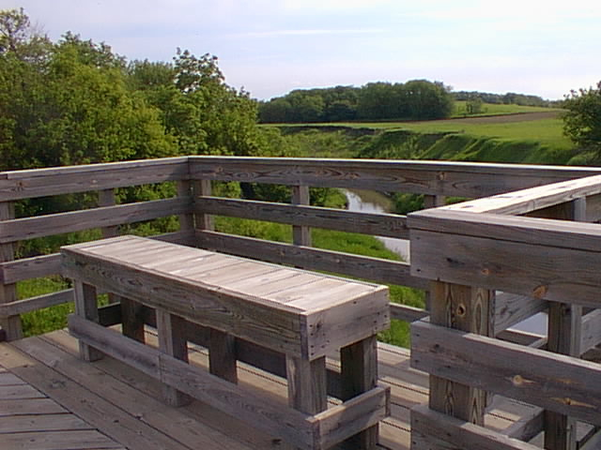
CENTURY RIDE
Southwest Iowa Nature Trails, Inc. (SWINT) is sponsoring a century ride on August 8 & 9, 2009. This is our 8th annual century ride, and it has grown in popularity each year. This ride will be a Weekend Mile Century that starts in Council Bluffs at the trailhead near Lewis Central School (see schedule). The ride will go through Mineola, Silver City, Malvern, Strahan, Imogene, Shenandoah, and finish at the old Izaak Walton League grounds (IKES) which is located about 5 miles southwest of Shenandoah on the Wabash. IKES is just north of the town of Bingham and is exactly 50 miles from the Council Bluffs trailhead. The return trip on Sunday will finish the Weekend Century.
Wabash Trace bridge over the Tarkio River. This is where you can view the Perseid Meteor shower on Saturday night.

If you would prefer the comfort of a bed, there are three motels in Shenandoah and guest houses in Coin. Transportation from IKES will be available.

The pool in Shenandoah is a great place to stop for a “cool dip”. Pack your swimsuit and towel on your bike and enjoy a free swim. Pool pass is in your ride packet.
SPECIAL 20th ANNIVERSARY KOOZIES FOR SALE! BIKE FRIENDLY!

BIKING THE WABASH
The purpose of this ride is to have fun, enjoy the natural beauty of the trail, and explore our small southwest Iowa towns. This is not a race! Have a leisurely ride. Stop along the way for a drink, lunch, snack, or a swim. The farmers market is open in Silver City with crafts, baked goods, and fresh produce. Mechanical and SAG support will be available along the trail.

ENTRY FEE INCLUDES
- Camping gear transport from Council Bluffs to IKES and back to Council Bluffs on Sunday.
- Dinner, beverages, camping site
- Entertainment, prizes, and games
- Sunday morning juice & fruit at The IKES and new breakfast coupon for The Depot Deli in Shenandoah
- T-shirt commemorating the event
- Mechanical support and SAG support
- Free swimming pass for Shenandoah pool, located in Sportsman’s Park right by the Wabash Trace.
- Ride packet with free information, pool pass, and trinkets.

REMEMBER Non-riders are welcome to join the riders for the dinner, entertainment, meteor ride and campout. See registration form for details.
SCHEDULE

SATURDAY MORNING
August 8, 2009
Council Bluffs Trailhead
8:00 to 10:00 AM – Check in. Check camping gear. Get ride packet and t-shirt.
ENJOY THE RIDE!

SATURDAY AFTERNOON
ARRIVAL AT IKES
Set up camp, shower, merchandise display, and social time.
6:00 to 8:00 PM – Dinner served. Wabash Trace items for sale – some closeouts!
8:00 PM – Entertainment and music
10:00 PM – Perseid Meteor show. Ride a few miles south of the campground to watch the meteor display.
12:00 PM – Lights out!

SUNDAY MORNING
August 9, 2009

8:00 TO 9:00 AM – Break camp and load camping gear to be returned to Council Bluffs trailhead.
Juice and fruit at The IKES and ride to Depot Deli for breakfast!
Begin second half of Century Ride
DIRECTIONS

Council Bluffs Trailhead
Take I-29 to Highway 92. East on Highway 92 to Wabash Avenue. South on Wabash Avenue past Lewis Central School Complex. Trailhead is located on South Omaha Bridge Road. Watch for signs.

Izaak Walton League (IKES)
Highway 59 south to Shenandoah. Go about 1 mile south of Shenandoah to Highway 2. Take Highway 2 east for about 4½ miles. Izaak Walton building on south side of highway.

IMPORTANT ITEMS
- All riders must wear an ANSI or SNELL approved bicycle helmet.
- Mechanical support will be available before and during the day’s events.
- Water and refreshments will be available in most of the towns along the trail.
- RIDE RIGHT! Please stay to the right of the trail and watch for traffic on country roads.
- Bicycle lights are required for night riding.
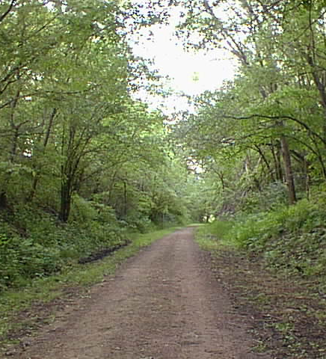
REGISTRATION FORM
Make checks payable to: SWINT
Mail to: SWINT
PO BOX 522,
COUNCIL BLUFFS IA 51502

Enclose registration form and check.
(Please print or type)

Name________________________________

Address_____________________________
City_________________________________
State__________________Zip___________
Phone Day____________Eve____________
EMAIL ADDRESS: _____________________
Number of Century Riders X $50 ______
Dinner & entertainment only X $10 ______
Total Enclosed $__________

T-shirt size and number of each size
S_____ M_____ L_____ XL_____ XXL_____

RELEASE FORM (Each rider must sign)
In signing this release, I acknowledge that I hereby agree and will absolve and hold harmless: Southwest Iowa Nature Trails, Inc., Iowa Natural Heritage Foundation, The City of Council Bluffs, Corporate Sponsors, cooperating organizations and any other parties connected with this event, signally or collectively from and against any blame and liability for any injury, misadventures, harm, loss, inconvenience or damage hereby suffered or sustained as a result of participation in the Wabash Century Ride, Campout, and Meteor Show. I also hereby consent to and permit emergency treatment in the event of injury or illness. I understand entry fees are non-refundable.

_________________________________________
Signature
Parent or Guardian must sign for all minors.
Please feel free to duplicate this brochure.

8TH ANNUAL

WABASH CENTURY CAMPOUT &
METEOR SHOW

AUGUST 8 & 9, 2009

A RIDING EXPERIENCE THROUGH SOUTHWEST IOWA

SPONSORED BY
WABASH TRACE NATURE TRAIL
SOUTHWEST IOWA NATURE TRAILS, INC.
&
IOWA NATURAL HERITAGE FOUNDATION

